**Pi1541-HAT Rev. 2**

**Prototype Testing**

# Test set-up

The testing setup was a C64G (ASSY 250469), standard kernel, no cartridge, connected to the Pi1541 (Device 8) which was then connected to a 1541-II (device 9).

Firmware version of Pi!541 was v1.19 (ROM: CBM DOS V2.6).

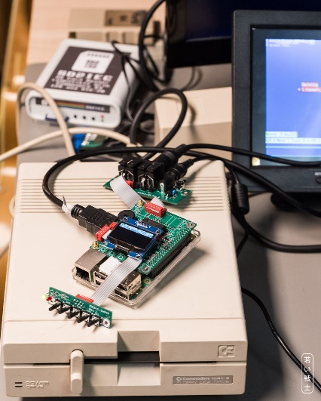

Figure 1: Test set-up

The external keyboard “Pi1541 Switch Rev. 1” was attached to the HAT with a ribbon cable (length 15cm) and the external IEC-connectors “Pi1541-IEC Rev. 0” was attached via a ribbon cable of approximately 15cm. The Pi1541 was powered with a 5V/4A PSU via the barrel connector on the Pi5141-IEC.

# Test

| **Test** | **Result** | **Testing** |
| --- | --- | --- |
| Powering from Micro-USB | Pi1541 boots and is functional | ok |
| Powering from Barrel connector | Pi1541 boots and is functional | ok |
| 1.3” OLED Display | Shows graphics and lists | ok |
| SW1 (select/Reset) | Selects Images and leaves them again | ok |
| SW2 (up) | Scrolling lists works | ok |
| SW3 (down) | Scrolling lists works | ok |
| SW4 (Exit Folder) | Exits Folder | ok |
| SW5 (Insert Disk) | In Browser mode, it enters a directory and leaps to the end of the list. Adding multi disks to a list. | ok |
| Power LED | Lights up while Pi1541 is powered | ok |
| Activity LED (LD1) | Lights while drive active | ok |
| Speaker | Produces sound on track stepping | ok |
| Loading “Ghost’n’Goblins” | Game loads and plays normally | ok |
| Loading “Barbarian II” | Loading, flipping disks works, game plays normally | ok |
| Loading “Creatures 2” | Loading, flipping disks works, game plays normally | ok |
| Loading “Defender of the crown” | Disk 1 loads normally and runs. Hooks up on flipping to disk 2.  See addendum. | ok |
| Copying Disk from Pi1541 to 1541-II with DraCopy | Worked several times | ok |
| Copying Disk from 1541-II to Pi1541 with DraCopy | Worked | ok |
| Loading the X’2018 demo “drinking buddy” | Demo loads and runs normally | ok |
| Copying “drinking buddy” to a floppy disk using DraCopy | Disk copied successfully, demo loads and runs normally from a floppy disk (temporarily: Pi1541 disconnected, 1541-II set to device 8) | ok |
| Copying “drinking buddy” from floppy disk to Pi1541using DraCopy | Disk copied successfully, demo loads and runs normally | ok |
| Loading X’2018 demo “dsr-x2018.d64” | Demo loads and runs normally | ok |
| Loading X’2018 demo “frantic4bhf.d64” | Demo loads and runs normally | ok |
| Loading X’2018 demo “unboxed side1.d64” | Demo loads and runs until inserting the image “unboxed side 2.d64”, then hooks up.  See addendum. | ok |
| Loading X’2018 demo “rewind.d64” | Demo loads and runs normally | ok |
| Loading X’2018 demo “starwars_s1.d64” | Demo loads and runs normally, flipping to disk 2 (s2): system hooks up”  See addendum. | ok |
| Loading Galencia with Final Cartridge III+ | Game loads and plays normally | ok |
| Loading L’Abbaye des Morts with Final Cartridge III+ | Game loads and plays normally | ok |

# Conclusion

The Pi1541 HAT and all attached boards seem to work properly. The problem with flipping disks occurs with modern software, that is assumed to detect the disk automatically. Leaving the disk image with “select” (SW1), navigating to the other disk image and selecting is again is not working in this case. A similar problem was observed when accidentally trying to load something from the P1541, while no disk image was selected. This causes a hook-up of the C64 even in plain BASIC mode. This is considered to be a software issue or a matter of the applied method of flipping disks.

Addendum:  
Adding the disks of a multi-disk game or demo works with adding them to a list with SW5. Then flipping disks can be achieved with SW2 and SW3 and select.

The system is fully functional.

# Rev. 2

Revision 2 was not yet tested, the modification is considered to be low risk. The Eagle design passed the Design Rule Check (DRC) and the Gerber Data was checked with a Gerber Viewer.